Sunday | Monday | Tuesday | Wednesday | Thursday | Friday | Saturday
 |  |  |  |  |  | 1
2 | 3 | 4 | 5 | 6 | 7 | 8
9 | 10 | 11 | 12 | 13 | 14 | 15
16 | 17 | 18 | 19 | 20 | 21 | 22
23 | 24 | 25 | 26 | 27 | 28 | 29
30 | 31

August 2026  Memory Care Calendar  Culture of the Month: Food is Fuel |  |  |  |  |  | 8:30 Sunrise Morning Chat & Culture of the Month  9:00 Carmel Village Stroll  9:30 Anatomy Trivia  10:00 Residents Choice Video  10:15 Morning Snack  11:00 Ladies Manicures + I Love Lucy  1:30 BINGO  2:30 Afternoon Snack  3:00 Cinema Hour~ Message in a Bottle+ Chips
National Book Coloring Day  8:30 Hallmark Movie  9:30 Scenic Drive~ Bus Driver Choice  10:15 Snack Break  11:00 Worship Music  1:30 Room Visits  2:00 Cat Coloring Pages  2:30 Afternoon Snack  3:15 Music Balloon Volleyball  4:00 America’s Got Talent | 9:00 Chair Yoga  9:30 Big Word Little Word  10:15 Snack Break  10:30 Jeopardy  11:00 Motor Skills Monday~ Color Ball Matching Game  1:30 Pastor Phil  2:30 Afternoon Snack  2:30 Happy Hour~ Iced Biscoff Latte | 8:30 Morning Chat  8:40 Old Wives Tales  9:00 Walking Club  9:30 Jeopardy  10:15 Snack Break  10:45 Nutrition Class 101  2:15 Cooking Class~ Water Gate Salad  2:30 Afternoon Snack  3:00 Residents Choice  4:00 Room Visits | 8:30 Daily Chronical  9:00 Gentle Stretches  9:30 Alphabet Game  10:15 Morning Snack  10:30 Lunch Outing~ Tahoe Joes  2:00 Music W/ Mathew Malcolm  2:30 Afternoon Snack  3:00 BINGO  4:00 Family Feud | National Root Beer Float Day  8:30 Daily Chronical  9:00 Chair Yoga  9:30 Hangman  10:15 Snack Break  10:45 Crafty Crew~ Claw Clip Decorating  2:00 Fun Fact Trivia  2:15 Root Beer Float Social  2:30 Afternoon Snack  3:00 Pretty Nails+ TV Sitcom  3:30 Room Visits | 8:30 Daily Chronical  8:40 Morning Reading Club  9:00 Noodle Exercise  10:15 Snack Break  11:00 Men’s Recreational Club~ Dominoes  2:00 Music W/ AL Turner  2:30 Afternoon Snack  2:30 Happy Hour~ Green Apple Spritzer  3:00 BINGO | 8:30 Sunrise Morning Chat  9:00 Carmel Village Stroll  9:30 Never Have I Ever Game  10:00 Residents Choice Video  10:15 Morning Snack  11:00 Ladies Manicures +TV Sitcom  1:30 BINGO  2:30 Afternoon Snack  3:00 Cinema Hour~ Charade + Chips
8:30 Hallmark Movie  9:30 Scenic Drive~ Woodward Park  10:15 Snack Break  11:00 Worship Music  1:30 Room Visits  2:30 Afternoon Snack  3:15 Music Balloon Volleyball  4:00 America’s Got Talent | 9:00 Chair Yoga  9:30 Big Word Little Word  10:15 Snack Break  10:30 Jeopardy  11:00 Motor Skills Monday~ Connect Four  1:30 Anatomy Trivia  2:30 Afternoon Snack  2:30 Happy Hour~ Green Apple Slushy | 8:30 Morning Chat  8:40 Old Wives Tales  9:00 Walking Club  9:30 Jeopardy  10:15 Snack Break  10:45 Nutrition Class 101  2:15 Cooking Class~ Zucchini Muffins  2:30 Afternoon Snack  3:00 Residents Choice  4:00 Room Visits | 8:30 Daily Chronical  9:00 Gentle Stretches  9:30 Alphabet Game  10:15 Morning Snack  11:00 Lunch Outing~ Famous Daves BBQ  2:00 Music W/ David Press  2:30 Afternoon Snack  3:00 BINGO  4:00 Family Feud | Food Around the World  8:30 Daily Chronical  9:00 Carmel Village Stroll  10:15 Snack Break  11:00 Food Around the World in AL  2:00 Craft Crew~ Lemon Tree Art  2:30 Afternoon Snack  3:00 Pretty Nails + TV Sitcom  3:30 Room Visits | 8:30 Daily Chronical  8:40 Morning Reading Club  9:00 Noodle Exercise  10:15 Snack Break  11:00 Men’s Recreational Club~ Farkle  2:00 Armchair Travels~ Boston Massachusetts  2:30 Afternoon Snack  2:30 Happy Hour~ Bostonian Mocktail  3:00 BINGO | 8:30 Sunrise Morning Chat  9:00 Carmel Village Stroll  9:30 Old Wives Tales  10:00 Residents Choice Video  10:15 Morning Snack  11:00 Ladies Manicures +TV Sitcom  2:15 Appreciation Snack for Staff~ Esquites  2:30 Afternoon Snack  3:00 Cinema Hour~ Rudy + Chips
8:30 Hallmark Movie  9:30 Scenic Drive~ Panera Bread Outing  10:15 Snack Break  11:00 Worship Music  1:30 Room Visits  2:30 Afternoon Snack  3:15 Music Balloon Volleyball  4:00 America’s Got Talent | 50’s Day  9:00 Chair Yoga  9:30 1950’s Trivia  10:15 Snack Break  10:30 1950’s Music Appreciation  11:00 Motor Skills Monday~ Balloon Volleyball  1:30 Elvis Presley Documentary  2:30 Afternoon Snack  2:30 Happy Hour~ The Strawberry Shortcake Mocktail | Red, White, and Blue Day  8:30 Morning News  9:00 Walking Club  9:30 Jeopardy  10:15 Snack Break  10:45 Nutrition Class 101  2:15 Cooking Class~ Make your own Smoothie Bar  2:30 Afternoon Snack  3:00 Residents Choice  4:00 Room Visits | Elvis Day!  8:30 Elvis Fun Facts  9:00 Gentle Stretches  9:30 Alphabet Game  10:15 Morning Snack  11:00 Elvis Presley Karaoke  1:30 Elvis Presley Movie  2:30 Afternoon Snack  3:00 Elvis in AL Dining Room Performance | Sock Hop Day  8:30 Daily Chronical  9:00 Chair Yoga  9:30 Hangman  10:15 Snack Break  10:45 Crafty Crew~ Cutip Flower Painting  2:00 Sock Hop Fun Facts  2:10 Sock Hop Trivia  2:30 Afternoon Snack  3:00 Pretty Nails + TV Sitcom  3:30 Room Visits | Rock ‘N’ Roll Friday  8:30 Daily Chronical  8:40 Morning Reading Club  9:00 Noodle Exercise  10:15 Snack Break  11:00 Men’s Recreational Club~ Building Legos  2:00 Music W/ Miriam G  2:30 Afternoon Snack  2:30 Happy Hour~ Dirty Diet Coke Float  3:00 BINGO | 8:30 Sunrise Morning Chat  9:00 Carmel Village Stroll  9:30 Funny Riddles  10:00 Residents Choice Video  10:15 Morning Snack  11:00 Ladies Manicures +TV Sitcom  1:30 BINGO  2:30 Afternoon Snack  3:00 Cinema Hour~ The Founder + Popcorn
8:30 Hallmark Movie  9:30 Scenic Drive~ Millerton Lake  10:15 Snack Break  11:00 Worship Music  1:30 Room Visits  2:30 Afternoon Snack  3:15 Music Balloon Volleyball  4:00 America’s Got Talent | 9:00 Chair Yoga  9:30 Big Word Little Word  10:15 Snack Break  10:30 Jeopardy  11:00 Motor Skills Monday~ Bowling  1:30 The Price is Right  2:30 Afternoon Snack  2:30 Happy Hour~ Beach Babe Mocktail | National Banana Split Day  8:30 Morning News  9:00 Walking Club  9:30 Jeopardy  10:15 Snack Break  10:45 Nutrition Class 101  2:15 Cooking Class~ Banana Split DIY Bar  2:30 Afternoon Snack  3:00 Residents Choice  4:00 Room Visits | 8:30 Daily Chronical  9:00 Gentle Stretches  9:30 Big Word Little Word  10:15 Morning Snack  10:30 Blossom Trail Café  2:00 Music W/ Randy  2:30 Afternoon Snack  3:00 BINGO  4:00 Family Feud | 8:30 Daily Chronical  9:00 Chair Yoga  9:30 Hangman  10:15 Snack Break  10:45 Crafty Crew~ Popsicle Houses  2:15 Happy Birthday Month Social~ Pancake Bar  2:30 Afternoon Snack  3:00 Resident’s Choice  3:30 Room Visits | 8:30 Daily Chronical  8:40 Morning Reading Club  9:00 Noodle Exercise  10:15 Snack Break  11:00 Men’s Recreational Club~ PCV Pipe  2:00 Afternoon Tea Social  2:30 Afternoon Snack  3:00 Residents Choice Movie | 8:30 Sunrise Morning Chat  9:00 Carmel Village Stroll  9:30 Old Wives Tales  10:00 Residents Choice Video  10:15 Morning Snack  11:00 Ladies Manicures +TV Sitcom  1:30 BINGO  2:30 Afternoon Snack  3:00 Cinema Hour~ A Walk To Remember + Popcorn
8:30 Sunday Morning Chat  9:30 Scenic Drive~ Herndon Avenue  10:15 Snack Break  11:00 Worship Music  2:00 Room Visits  2:30 Afternoon Snack  3:15 Music Balloon Volleyball  4:00 America’s Got Talent | 9:00 Chair Yoga  9:30 Big Word Little Word  10:15 Snack Break  10:30 Jeopardy  11:00 Motor Skills Monday~ Kickball  1:30 Jeopardy  2:30 Afternoon Snack  2:30 Happy Hour~ Cherry Blossom Spritz | 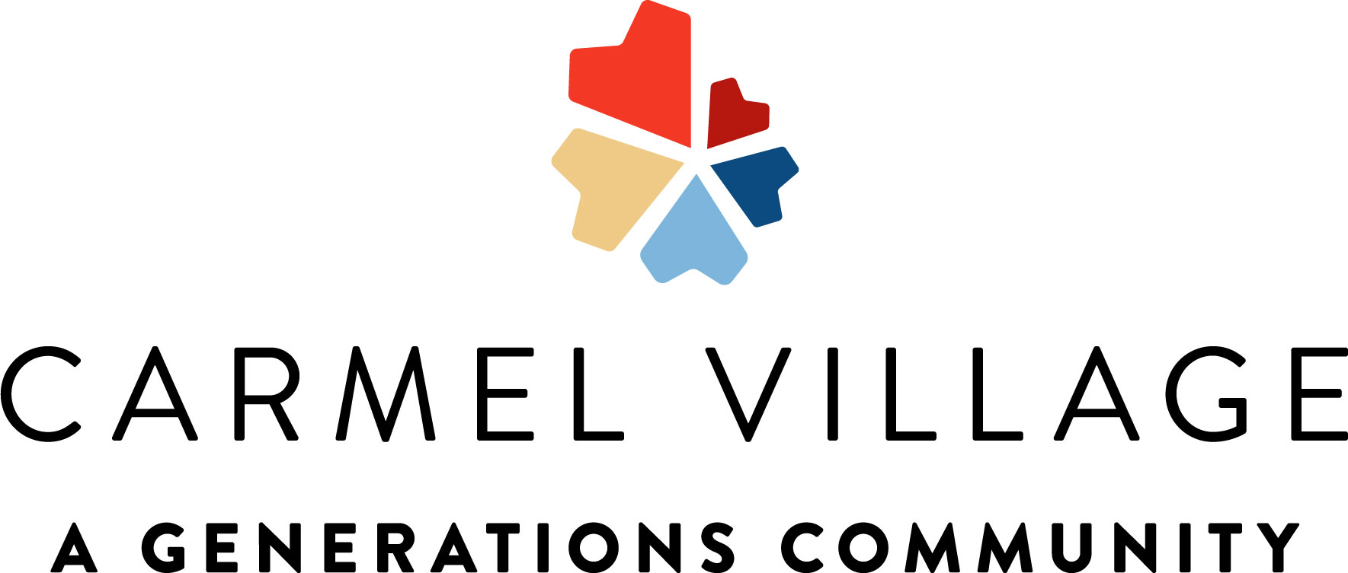
2145 Standford Ca #107208996 **Activities Subject to Change**

