April 2026  Memory Care Calendar  Culture of the month: Celebrating Generations Values |  |  | April Fool’s Day:  Crazy Hair and Mix Match Day  8:30 Morning Chat  9:00 Gentle Stretches  9:30 April Fools Staff Planning Support  10:15 Morning Snack  10:30 Room Visits  11:00 Lunch Outing~ Flight Line Café  2:00 Music W/Mathew Malcolm  2:30 Afternoon Snack  3:00 BINGO  4:00 Jeopardy | 8:30 Morning News  9:00 Walking Club  9:30 Hangman  10:15 Snack Break  11:00 Easter BINGO  2:15 Cooking Class~ Chocolate Chip Cookies  2:30 Afternoon Snack  3:00 Residents Choice | 8:30 Daily Chronical  9:00 Noodle Exercise  10:15 Snack Break  10:30 Book Club~ Pride and Prejudice  11:00 Men’s Recreational Club~ Jenga  2:00 Music W/ AL Turner  2:30 Afternoon Snack  2:30 Happy Hour~ Raspberry Spritzer  3:00 Room Visits | Easter Egg-Stravaganza  10:30-2pm in AL Patio  10:15 Morning Snack  11:00 Fun Facts Trivia  2:00 Hallmark Movie  2:30 Afternoon Snack  3:00 Cinema Hour~ It’s Complicated
Happy Easter Sunday!  8:30 Sunday Morning  9:30 Scenic Drive~ Woodward Park  10:15 Snack Break  11:00 Worship Music  2:00 Free Coloring Time  2:30 Afternoon Snack  3:15 Music Balloon Volleyball | 8:30 Monday Morning Chat  8:45 What is the culture of the month  9:00 Get Fit Stay Fit  9:30 Name that Tune  10:15 Snack Break  11:00 Motor Skills Monday~ Balloon Volleyball  1:30 Pastor Phil  2:30 Afternoon Snack  3:15 Happy Hour~ Blue Peep Cocktail | 8:30 Daily Chronical  9:00 Zumba  9:30 The price is Right  10:15 Snack Break  10:30 Crafty Crew ~ No Sew Bunny Craft  2:00 Word Wheels G  2:30 Afternoon Snack  3:00 Ladies Manicures+ TV Sitcom | 8:30 Morning Chat  9:00 Gentle Stretches  9:30 Guess the Riddles  10:15 Morning Snack  10:30 Room Visits  11:00 Lunch Outing~ Andiamo’s Italian  2:00 Music W/David Press  2:30 Afternoon Snack  3:00 BINGO  4:00 Jeopardy | 8:30 Morning News  9:00 Walking Club  9:30 Balloon Noodle Hockey  10:15 Snack Break  11:00 Old Wives Tales in the Patio  2:15 Cooking Class~ Smoothie Bar  2:30 Afternoon Snack  3:00 Residents Choice | 8:30 Daily Chronical  9:00 Noodle Exercise  10:15 Snack Break  10:30 Book Club~ Pride and Prejudice  11:00 Men’s Recreational Club~ Farkle  2:15 Staff Appreciation Snack and Pictures  2:30 Afternoon Snack  2:30 Happy Hour~ Paloma Mocktail  3:00 Room Visits | 8:30 Sunrise Morning Chat  8:45 Carmel Village Stroll  10:00 Breakfast at Tiffany’s Social  10:15 Morning Snack  2:00 BINGO  2:30 Afternoon Snack  3:00 Cinema Hour~ Breakfast at Tiffany + Popcorn
8:30 Sunday Morning Chat  9:30 Scenic Drive~ Mickey’s Frozen Yogurt  10:15 Snack Break  11:00 Worship Music  2:00 Find the Difference  2:30 Afternoon Snack  3:15 Music Balloon Volleyball | 8:30 Monday Morning Chat  9:00 Get Fit Stay Fit  9:30 Fun Fact Trivia  10:15 Snack Break  10:30 Hangman  11:00 Name that Tune  1:45 Motor Skills Monday~ Giant Connect Four  2:30 Afternoon Snack  3:15 Happy Hour~ Pink Iced Coconut Latte | 8:30 Daily Chronical  9:00 Zumba  9:30 The price is Right  10:15 Snack Break  10:45 Crafty Crew W/Hinds Hospice~ Paper Mache Flowers  2:00 Biology Trivia  2:30 Afternoon Snack  3:00 Ladies Manicures + TV Sitcom | Sinking of the Titanic Anniversary  8:30 Morning Chat  9:00 Gentle Stretches  9:30 History of the Titanic and Titanic Museum Video  10:15 Morning Snack  10:30 Room Visits  11:00 Lunch Outing~ Haciendas Tequila  1:30 Titanic Movie  2:30 Afternoon Snack  3:00 BINGO  4:00 Jeopardy | 8:30 Morning News  9:00 Walking Club  9:30 Hangman  10:15 Snack Break  11:00 1920’s Trivia  2:30 Rocking 50’s Social  2:30 Afternoon Snack  3:00 Residents Choice | 8:30 Daily Chronical  9:00 Noodle Exercise  10:15 Snack Break  10:30 Book Club~ Pride and Prejudice  11:00 Men’s Recreational Club~ PCV Pipe  2:00 Music W/ Miriam G  2:30 Afternoon Snack  2:30 Happy Hour~ Blue Lagoon Mocktail  3:00 Room Visits | 8:30 Sunrise Morning Chat  9:00 Carmel Village Stroll  9:30 Jeopardy  10:15 Morning Snack  11:00 Ladies Manicures  2:00 BINGO  2:30 Afternoon Snack  3:00 Cinema Hour~ The Pursuit of Happyness+ Popcorn
Rodeo Week:  Bandana Day  8:30 Sunday Morning Chat  9:30 Scenic Drive~ Fig Garden  10:15 Snack Break  11:00 Worship Music  2:00 Free Coloring Time  2:30 Afternoon Snack  3:15 Music Balloon Volleyball | Rodeo Week:  Cowboy Boots  8:30 Monday Morning Chat  9:00 Get Fit Stay Fit  9:30 Cowboy Roping Video  10:15 Snack Break  10:30 Cowboy Coloring Pages  11:00 America’s Got Talent  1:45 Motor Skills Monday~  2:30 Afternoon Snack  3:15 Happy Hour~ Lemon Curd Fizz Mocktail | Rodeo Week:  Farmers Day  8:30 Daily Chronical  9:00 Zumba  9:30 Farm Trivia  10:00 Food Systems Class  10:15 Snack Break  10:30 Crafty Crew~ DIY Cowboy Hats  2:15 Armchair Travels~ Oklahoma  2:30 Afternoon Snack  3:00 Ladies Manicures+ TV Sitcom | Rodeo Week:  Cow print and Sparkles  Happy Earth Day!  8:30 Morning Chat  9:00 Outdoor Carmel Village Walk  9:30 Pollination Class  10:15 Morning Snack  10:30 Room Visits  11:00 Lunch Outing~ In N Out  2:00 Music W/ Randy  2:30 Afternoon Snack  3:00 BINGO  4:00 Jeopardy | Rodeo Week:  Classic Western Day  8:30 Morning News  9:00 Walking Club  9:30 Alphabet Game  10:15 Snack Break  11:00 Fun Facts Trivia  2:15 Cooking Class~ DIY Sundae Bar  2:30 Afternoon Snack  3:00 Residents Choice  Hoedown Dance in AL Lobby  5:30-7pm | Rodeo Week:  Flannel Day  8:30 Daily Chronical  9:00 Noodle Exercise  10:15 Snack Break  10:30 Book Club~ Pride and Prejudice  11:00 Men’s Recreational Club~ Giant Connect Four  2:30 Happy Birthday Month Social  2:30 Afternoon Snack  3:00 Room Visits | Rodeo Week:  Happy Birthday America  9:00 Carmel Village Stroll  9:30 Jeopardy  10:15 Morning Snack  11:00 Ladies Manicures  2:00 BINGO  2:30 Afternoon Snack  3:00 Cinema Hour~ Pride and Prejudice + Popcorn
8:30 Sunday Morning Chat  9:30 Scenic Drive~ Temperance Avenue  10:15 Snack Break  11:00 Worship Music  2:00 Find the Difference  2:30 Afternoon Snack  3:15 Music Balloon Volleyball | 8:30 Monday Morning Chat  9:00 Get Fit Stay Fit  9:30 Animal Videos  10:15 Snack Break  10:30 Hangman  11:00 Name that Tune  1:45 Motor Skills Monday~  2:30 Afternoon Snack  3:15 Happy Hour~ Cotton Candy Pink Lemonade Mocktail | National Blueberry Pie Day  8:30 Daily Chronical  9:00 Zumba  9:30 The price is Right  10:15 Snack Break  10:30 Crafty Crew ~ Kentucky Derby Hats  2:00 Blueberry Pies Social  2:30 Afternoon Snack  3:00 Ladies Manicures+ TV Sitcom | 8:30 Morning Chat  9:00 Gentle Stretches  9:30 Old Wives Tales  10:15 Morning Snack  10:30 Room Visits  11:00 Lunch Outing~ Woodward American Grill  2:00 Karaoke W/ Denise  2:30 Afternoon Snack  3:00 BINGO  4:00 Jeopardy | 8:30 Morning News  9:00 Walking Club  9:30 Hangman  10:15 Snack Break  11:00 Music Appreciation 1930’s  2:15 Cooking Class~ No Bake Oreo Cheesecake  2:30 Afternoon Snack  3:00 Residents Choice | 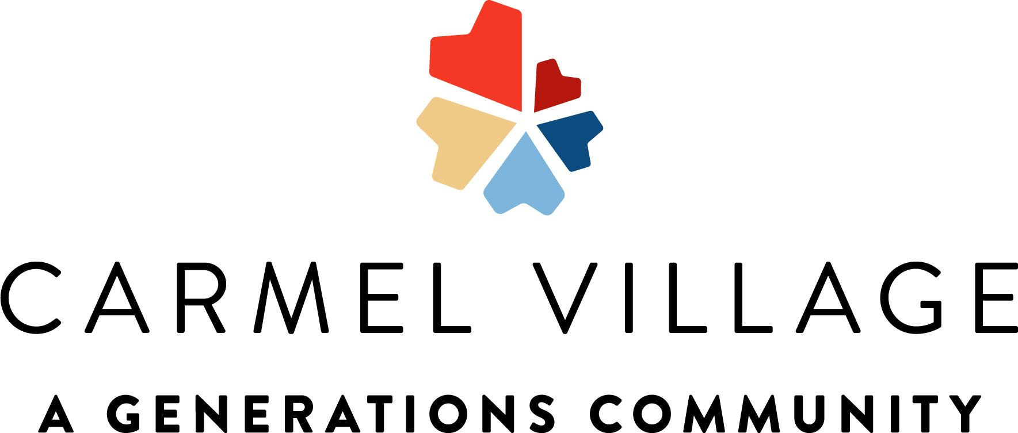
2145 Standford Ca #107208996 **Activities Subject to Change**
Sunday | Monday | Tuesday | Wednesday | Thursday | Friday | Saturday
 |  |  | 1 | 2 | 3 | 4
5 | 6 | 7 | 8 | 9 | 10 | 11
12 | 13 | 14 | 15 | 16 | 17 | 18
19 | 20 | 21 | 22 | 23 | 24 | 25
26 | 27 | 28 | 29 | 30

