8:30 Morning News  9:30 Scenic Drive~ Sanger, Ca  10:15 Snack Break  11:00 Worship Music  2:00 Free Coloring Time  2:30 Afternoon Snack  3:15 Music Balloon Volleyball |  | Dr. Seuss Day  8:30 Monday Morning Chat  9:00 Get Fit Stay Fit  9:30 Dr. Seuss Trivia  10:15 Snack Break  10:30 What is the Culture of the Month?  11:00 Pastor Phil  1:45 Motor Skills Monday~ Bowling  2:30 Afternoon Snack  3:15 Happy Hour~ Surprise Spritzer  3:30 Dr. Seuss Movie~ The Cat in the Hat |  | 8:30 Daily Chronical  9:00 Zumba  9:30 The price is Right  10:15 Snack Break  10:30 Crafty Crew ~ DIY Picture Frames  2:00 Word Wheels Game  2:30 Afternoon Snack  3:00 Pretty Nails + TV Sitcom | 8:30 Morning Chat  9:00 Gentle Stretches  9:30 Big Word Little Word  10:15 Morning Snack  10:30 Room Visits  12:00 Movie Outing~ EPiC: Elvis Presley in Concert  2:00 Music W/ Mathew Malcolm  2:30 Afternoon Snack  3:00 BINGO  4:00 Jeopardy | 8:30 Morning News  9:30 Outside Exercise in AL W/ Vitality Coordinators  10:15 Snack Break  11:00 Poetry in the Patio  2:15 Cooking Class~Bologne Sandwiches  2:30 Afternoon Snack  3:00 Residents Choice | 8:30 Daily Chronical  9:00 Zumba  10:15 Snack Break  10:30 Book Club~ Pride and Prejudice  11:00 Men’s Recreational Club~ Dominoes  2:00 Music W/ AL Turner  2:30 Afternoon Snack  2:30 Happy Hour~ Spicy Guava Margaritas  3:00 Room Visits | 8:30 Sunrise Morning Chat  9:00 Carmel Village Stroll  9:30 Jeopardy  10:15 Morning Snack  11:00 Ladies Manicures  1:45 Afternoon Stretches  2:00 BINGO  2:30 Afternoon Snack  3:00 Cinema Hour~ The Terminal + Popcorn
Day Light Savings  Spring Forward  8:30 Morning News  9:30 Scenic Drive~ Auberry Drive  10:15 Snack Break  11:00 Worship Music  2:00 Guess the Riddle  2:30 Afternoon Snack  3:15 Music Balloon Volleyball | 8:30 Monday Morning Chat  9:00 Get Fit Stay Fit  9:30 Animal Videos  10:15 Snack Break  10:30 Hangman  11:00 America’s Got Talent  1:45 Motor Skills Monday~ Balloon Volleyball  2:30 Afternoon Snack  3:15 Happy Hour~ Banana Matcha Latte |  | 8:30 Daily Chronical  9:00 Zumba  9:30 Spring Trivia Questions  10:15 Snack Break  10:30 Crafty Crew ~ Flowerpot Painting W/ Seva Hospice  2:00 Hula Hoop Game  2:30 Afternoon Snack  3:00 Pretty Nails +TV Sitcom |  | 8:30 Morning Chat  9:00 Gentle Stretches  9:30 Big Word Little Word  10:15 Morning Snack  10:30 Room Visits  11:00 Lunch Outing~ Yard House  2:00 Music W/David Press  2:30 Afternoon Snack  3:00 BINGO  4:00 Jeopardy | National Popcorn Lovers Day  8:30 Morning News  9:00 Walking Club  9:30 Alphabet Game  10:15 Snack Break  11:00 Poetry in the Patio  2:15 Cooking Class~ Sweet & Salty Popcorn Mix  2:30 Afternoon Snack  3:00 Residents Choice | 8:30 Daily Chronical  9:00 Zumba  10:15 Snack Break  10:30 Book Club~ Pride and Prejudice  11:00 Men’s Recreation Club~ Farkle  2:00 Name that Tune  2:30 Afternoon Snack  2:30 Happy Hour~ Shamrock Shake  3:00 Room Visits | 8:30 Sunrise Morning Chat  9:00 Carmel Village Stroll  9:30 Jeopardy  10:15 Morning Snack  11:00 Ladies Manicures  2:15 Bridgerton Tea Party  2:30 Afternoon Snack  3:00 Cinema Hour~ Bridgerton Show + Popcorn
8:30 Morning News  9:30 Scenic Drive~ Starbucks  10:15 Snack Break  11:00 Worship Music  2:00 Free Coloring Time  2:30 New Joy Church  2:30 Afternoon Snack  3:15 Music Balloon Volleyball | 8:30 Monday Morning Chat  9:00 Get Fit Stay Fit  9:30 Animal Videos  10:15 Snack Break  10:30 Hangman  11:00 Find the Difference  1:45 Motor Skills Monday~ Memory Recall Game  2:30 Afternoon Snack  3:15 Happy Hour~ Green Apple Dirty Mocktail |  | Happy St. Patrick’s Day!  8:30 Daily Chronical  9:00 Zumba  9:30 St. Patrick’s Trivia  10:15 Snack Break  10:30 Crafty Crew ~ St. Patrick’s Craft W/ Hinds Hospice  2:15 St. Patrick’s Day Social  2:30 Afternoon Snack |  | 8:30 Morning Chat  9:00 Gentle Stretches  9:30 Big Word Little Word  10:15 Morning Snack  10:30 Room Visits  11:00 Lunch Outing~ McDonald’s  2:00 Elvis Presley Music Appreciation  2:30 Afternoon Snack  3:00 BINGO  4:00 Jeopardy | 8:30 Morning News  9:00 Walking Club  9:30 Hangman  10:15 Snack Break  11:00 Balloon Tic Tac Toe  2:15 Taco About a Taco Bar Social  2:30 Afternoon Snack  3:00 Residents Choice | 8:30 Daily Chronical  9:00 Zumba  10:15 Snack Break  10:30 Book Club~ Pride and Prejudice  11:00 Men’s Recreational Club~ Trivia  2:00 Music W/ Miriam G  2:30 Afternoon Snack  2:30 Happy Hour~ Horchata Latte  3:00 Room Visits | World Poetry Day  8:30 Sunrise Morning Chat  9:00 Carmel Village Stroll  9:45 Poetry Appreciation  10:15 Morning Snack  11:00 Ladies Manicures  1:45 Afternoon Stretches  2:00 BINGO  2:30 Afternoon Snack  3:00 Cinema Hour~ The God Father+ Popcorn
9:30 Scenic Drive ~ Shepherd Ave  10:15 Snack Break  11:00 Worship Music  2:30 Afternoon Snack  2:00 Guess the Riddle  3:15 Music Balloon Volleyball | National Chip and Dip Day  8:30 Monday Morning Chat  9:00 Get Fit Stay Fit  9:30 Animal Videos  10:15 Snack Break  10:30 Big Word Little Word  11:00 Find the Difference  1:45 Motor Skills Monday~ Cup Stacking Challenge  2:30 Afternoon Snack  2:30 Chip and Dip W/ Veatrice +  Happy Hour~ Lime Shock Punch Mocktail |  | 8:30 Daily Chronical  9:00 Zumba  9:30 Japanese Fun Facts  10:15 Snack Break  10:30 Crafty Crew ~ Cherry Blossom Trees Painting  2:00 Armchair Travels ~ Japan  +Bento Boxes  2:30 Afternoon Snack  3:15 Japanese Movie~ Howl’s Moving Castle |  | Baseball Opening Day  8:30 Morning Chat  9:00 Gentle Stretches  9:30 Big Word Little Word  10:15 Morning Snack  10:30 Room Visits  11:00 Lunch Outing~ Hino Oishi  2:00 Music W/Randy  2:30 Afternoon Snack  3:00 BINGO  4:00 Jeopardy | Stagecoach Day  8:30 Morning News  9:30 Outside Exercise in AL W/ Vitality Coordinators  10:15 Snack Break  11:00 Alphabet Game  2:15 Cooking Class~ Churro Bites  2:30 Afternoon Snack  3:00 Residents Choice  6:00 Movie Night~ Stagecoach in AL Lobby | 8:30 Daily Chronical  9:00 Zumba  10:15 Snack Break  10:30 Book Club~ Pride and Prejudice  11:00 Men’s Recreational Club~ PCV Class  2:15 Happy Birthday Month Social  2:15 Happy Hour~ Cinderella Mocktail  2:30 Afternoon Snack  3:00 Room Visits | 8:30 Sunrise Morning Chat  9:00 Carmel Village Stroll  9:30 Jeopardy  10:15 Morning Snack  11:00 Ladies Manicures  1:45 Afternoon Stretches  2:00 BINGO  2:30 Afternoon Snack  3:00 Cinema Hour~ Julie & Julia + Popcorn
9:30 Scenic Drive~  Valley Children’s Loop  10:15 Snack Break  11:00 Worship Music  2:00 Free Coloring Time  2:30 Afternoon Snack  3:15 Music Balloon Volleyball | 8:30 Monday Morning Chat  9:00 Get Fit Stay Fit  9:30 Animal Videos  10:15 Snack Break  10:30 Big Word Little Word  11:00 America’s Got Talent  1:45 Motor Skills Monday~ Flower Matching Game  2:30 Afternoon Snack  3:15 Happy Hour~ Orange Pop Drink |  | 8:30 Daily Chronical  9:00 Zumba  9:30 Spring Trivia Questions  10:15 Snack Break  10:30 Crafty Crew ~ Bow Tie Butterfly Art  2:00 Tropical Fruit Bar Social  2:30 Afternoon Snack  3:00 Pretty Nails +TV Sitcom |  | March 2026 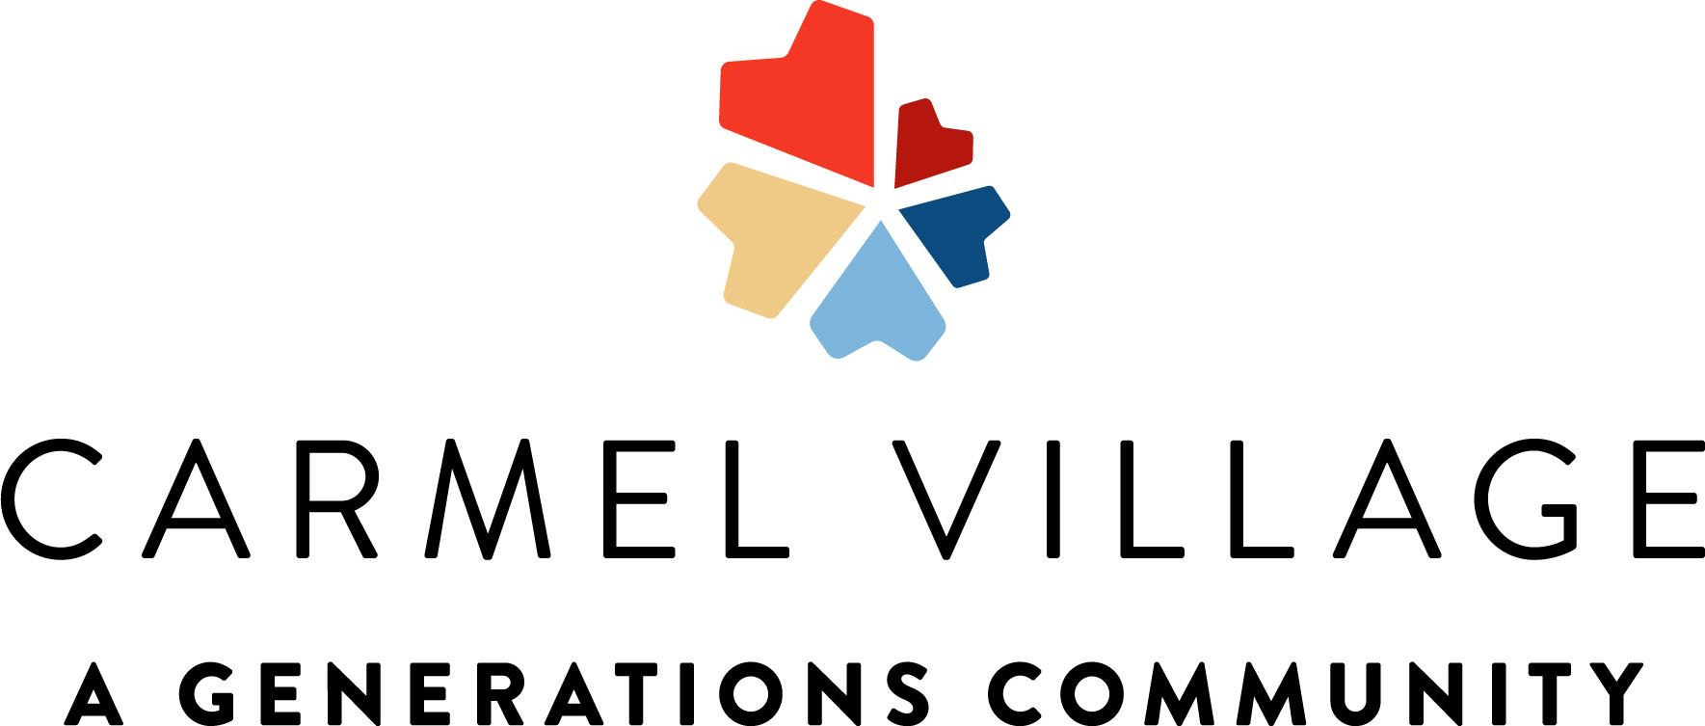  Memory Care Calendar  Culture of the month: Move More in March
2145 Standford Ca #107208996 **Activities Subject to Change**
Sunday | Monday | Tuesday | Wednesday | Thursday | Friday | Saturday
1 | 2 | 3 | 4 | 5 | 6 | 7
8 | 9 | 10 | 11 | 12 | 13 | 14
15 | 16 | 17 | 18 | 19 | 20 | 21
22 | 23 | 24 | 25 | 26 | 27 | 28
29 | 30 | 31

