Sunday | Monday | Tuesday | Wednesday | Thursday | Friday | Saturday
 |  |  |  |  | 1 | 2
3 | 4 | 5 | 6 | 7 | 8 | 9
10 | 11 | 12 | 13 | 14 | 15 | 16
17 | 18 | 19 | 20 | 21 | 22 | 23
24 | 25 | 26 | 27 | 28 | 29 | 30
31

May 2026  Memory Care Calendar  Culture of the Month: Mental Health Awareness Month |  |  |  |  | 8:30 Daily Chronical  9:00 Noodle Exercise  9:20 What is the Culture of the Month?  9:30 Hangman  10:15 Snack Break  10:30 Trivia Crush Game  11:00 Kentucky Derby Horse Race  2:00 Music W/ AL Turner  2:30 Afternoon Snack  2:30 Happy Hour~ Mint Julep Mocktail  3:00 Room Visits | Kentucky Derby Day  8:30 Sunrise Morning Chat  9:00 Chair Yoga  9:30 Kentucky Derby Trivia  10:15 Morning Snack  11:00 Mindfulness BINGO  1:30 Law & Order  2:30 Afternoon Snack  3:00 Baile Folklorico in AL Lobby
8:30 Sunday Morning Chat  9:30 Scenic Drive~ Bus Driver Choice  10:15 Snack Break  11:00 Worship Music  1:30 Loteria Game  2:30 Afternoon Snack  3:00 Room Visits | May the 4th be with you  9:00 Chair Yoga  9:30 Star Wars Fun Facts  10:15 Snack Break  10:30 Would you rather Star Wars Questions  11:00 Motor Skills Monday~ Star Wars Dot to Dot Page  1:30 Pastor Phil  2:30 Afternoon Snack  2:30 Happy Hour~ Blue Lemonade Refresher | Happy Cinco De Mayo  8:30 Cinco de Mayo Facts & Traditions  9:00 Get Fit Stay Fit  9:30 The price is Right  10:15 Snack Break  10:45 Crafty Crew ~ DIY Paper Bag Pinata  2:30 Afternoon Snack  2:30 Happy Hour~ Mango Frozen Margaritas  3:15 The Mask of Zorro Movie | 9:00 Community Outing~  Zoo Outing  9:30 100 Questions Trivia  10:15 Morning Snack  10:30 Room Visits  2:00 Music W/ Mathew Malcolm  2:30 Afternoon Snack  3:00 BINGO  4:00 Jeopardy | National Day of Prayer  8:30 Morning News  9:00 Walking Club  9:30 Balloon Noodle Hockey  10:15 Snack Break  10:45 Prayer Journals  2:15 Cooking Class~ Donut Holes  2:30 Afternoon Snack  3:00 Residents Choice | 8:30 Daily Chronical  9:00 Noodle Exercise  9:30 Big Word Little Word  10:15 Snack Break  11:00 Men’s Recreational Club~ Pokeno  2:00 BINGO  2:30 Afternoon Snack  2:30 Happy Hour~ Passionfruit Spritzer  3:00 Room Visits  4:30 Mother’s Day Dinner | 8:30 Sunrise Morning Chat  9:00 Carmel Village Stroll  9:30 Funny Animal Videos  10:15 Morning Snack  10:45 Mother Day Centerpieces  1:30 Mother’s Day Spa in AL  2:30 Afternoon Snack  3:00 Cinema Hour~ Sandlot + Popcorn
Happy Mother’s Day  8:30 Sunday Morning Chat  10:00 Donuts & Coffee W/ Mom  10:15 Snack Break  11:00 Worship Music  2:00 Calendar Girls Film  2:30 Afternoon Snack | 8:30 Monday Morning Chat  9:00 Chair Yoga  9:30 Fun Fact Trivia  10:15 Snack Break  10:30 Positive Talks W/ Veatrice  11:00 Hangman  1:30 Motor Skills Monday~ Balloon Volleyball  2:30 Afternoon Snack  3:15 Happy Hour~ Strawberry Matcha Milk Latte | 8:30 Daily Chronical  9:00 Get Fit Stay Fit  9:30 5 Facts of Mental Health  9:45 The price is Right  10:15 Snack Break  10:45 Crafty Crew~ Train Stencil Art  2:00 Anatomy Trivia  2:30 Afternoon Snack  3:15 Pretty Nails & Hallmark Movie | 8:30 Morning Chat  9:00 Gentle Stretches  9:30 Positive Affirmations  10:15 Morning Snack  10:30 Room Visits  11:00 Lunch Outing~ Blossom Trail Cafe  2:00 Music W/David Press  2:30 Afternoon Snack  3:00 BINGO  4:00 Jeopardy | 8:30 Morning News  9:00 Hallmark Movie  9:30 Outdoor Exercise in Patio  10:15 Snack Break  11:00 Roll the Dice and Say Something Nice Game  2:15 Cooking Class~ Banana Sushi Rolls  2:30 Afternoon Snack  3:00 Residents Choice | 8:30 Daily Chronical  9:00 Noodle Exercise  9:30 Indoor Bowling  10:15 Snack Break  10:45 Mindfulness BINGO  2:30 Parisian Tea Social  2:30 Afternoon Snack  3:00 Room Visits | National Armed Forces Day  8:30 Sunrise Morning Chat  9:00 Chair Yoga  9:45 Veteran Presentation  10:00 Armed Forces Video  10:15 Morning Snack  11:00 Ladies Manicures + TV Sitcom  2:00 BINGO  2:30 Afternoon Snack  3:00 Cinema Hour~ The Six Triple Eight + Popcorn
8:30 Sunday Morning Chat  9:30 Scenic Drive~ Kingsburg, Ca  10:15 Snack Break  11:00 Worship Music  2:00 New Joy Church  2:30 Afternoon Snack  3:00 Room Visits | 8:30 Monday Morning Chat  9:00 Chair Yoga  9:30 Fun Fact Trivia  10:15 Snack Break  10:30 Positive Talks W/ Veatrice  11:00 Name that Tune  1:30 Motor Skills Monday~ Flower Mix Match Game  2:30 Afternoon Snack  3:15 Happy Hour~ Green Apple Spritzer | 8:30 Daily Chronical  9:00 Get Fit Stay Fit  9:30 Paris France Fun Facts  10:15 Snack Break  10:45 Crafty Crew ~ Eiffel Tower Painting  2:15 Armchair Travels~ Paris, France  2:30 Afternoon Snack  3:00 Pretty Nails & Hallmark Movie | 8:30 Morning Chat  9:00 Gentle Stretches  9:30 Positive Affirmations  10:15 Morning Snack  10:30 Room Visits  11:00 Lunch Outing~ Seven Bar and Grill Cafe  2:00 Karaoke  2:30 Afternoon Snack  3:00 BINGO  4:00 Jeopardy | National Strawberries and Cream Day  8:30 Morning News  9:00 The Price is Right  9:30 Outdoor Exercise in Patio  10:15 Snack Break  11:00 Finish the phrase Trivia  2:15 Cooking Class~ Strawberry Shortcakes  2:30 Afternoon Snack  3:00 Residents Choice | 8:30 Daily Chronical  9:00 Noodle Exercise  10:15 Snack Break  11:00 Men’s Recreational Club~ Reminiscing Conversations and mocktails in Patio  2:00 Music W/ Miriam G  2:30 Afternoon Snack  2:30 Happy Hour~ Root Beer Floats  3:00 Room Visits | Car Wash Day in AL Parking Lot  10:15 Morning Snack  11:00 Jeopardy  2:00 Fun Facts Trivia  2:30 Afternoon Snack  3:00 Cinema Hour~ Casablanca
8:30 Sunday Morning Chat  9:30 Scenic Drive~ Panera Bread  10:15 Snack Break  11:00 Worship Music  2:00 Room Visits  2:30 Afternoon Snack  3:15 Music Balloon Volleyball | Memorial Day  8:30 Memorial Day Chat  9:00 Chair Yoga  9:30 Memorial Trivia  10:15 Snack Break  10:30 Positive Talks W/ Veatrice  11:00 Elvis Presley Sing Along  1:30 Motor Skills Monday~ Roll the Dice and Say Something Nice Game  2:30 Afternoon Snack  3:15 Happy Hour~ Korean Mango Milk | 8:30 Daily Chronical  9:00 Get Fit Stay Fit  9:30 5 Facts of Mental Health  9:45 The price is Right  10:15 Snack Break  10:50 Crafty Crew W/ Hinds Hospice  2:00 Anatomy Trivia  2:30 Afternoon Snack  3:00 Pretty Nails & Hallmark Movie | 8:30 Morning Chat  9:00 Gentle Stretches  9:30 The Price is Right  10:15 Morning Snack  10:30 Room Visits  11:00 Lunch Outing~ Pad Thai  2:00 Music W/ Randy  2:30 Afternoon Snack  3:00 BINGO  4:00 Jeopardy | 8:30 Morning News  9:00 Walking Club  9:30 Outdoor Exercise in Patio  10:15 Snack Break  11:00 Hawaiian Fun Facts  2:15 Hawaiian Social  2:30 Afternoon Snack  3:00 Residents Choice | 8:30 Daily Chronical  9:00 Noodle Exercise  10:15 Snack Break  11:00 Men’s Recreational Club~ Dominoes  2:30 Happy Birthday Social  2:30 Afternoon Snack  3:00 Room Visits | 8:30 Sunrise Morning Chat  9:00 Carmel Village Stroll  9:30 UNO Card Game  10:15 Morning Snack  11:00 Ladies Manicures +TV Sitcom  2:00 BINGO  2:30 Afternoon Snack  3:00 Cinema Hour~ Mamma Mia + Popcorn
8:30 Sunday Morning Chat  9:30 Scenic Drive~ Reedley, Ca  10:15 Snack Break  11:00 Worship Music  2:00 Room Visits  2:30 Afternoon Snack  3:15 Music Balloon Volleyball | 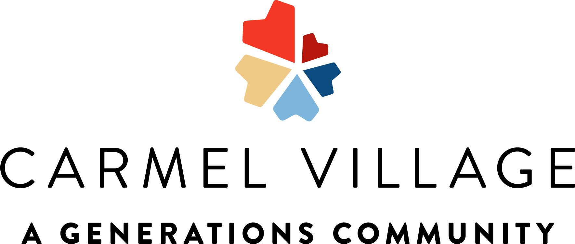
2145 Standford Ca #107208996 **Activities Subject to Change**

