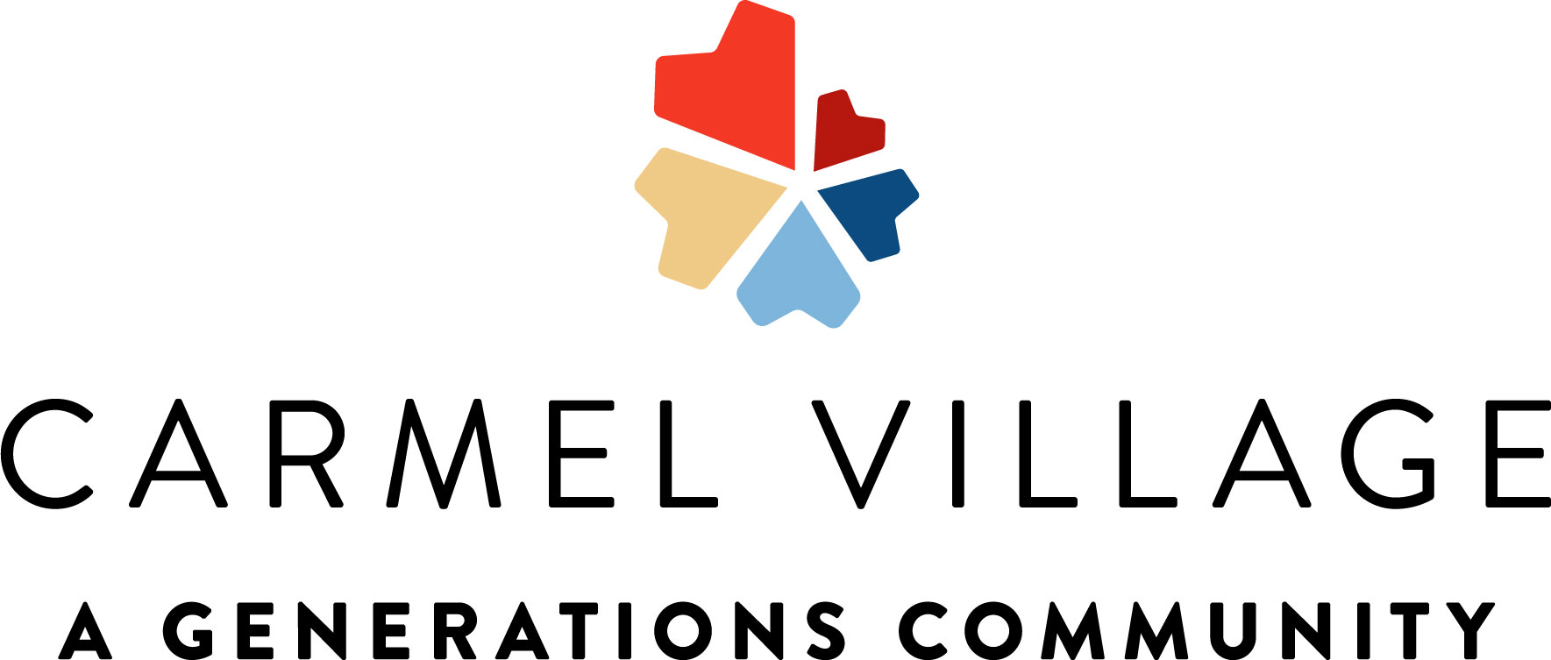 |  |  | 8:30 Daily Chronical  8:40 Let’s Talk About: Culture of the Month  9:00 Noodle Hockey Game  9:30 Jeopardy  10:15 Snack Break  10:45 Funny Animal Videos  2:15 Cooking Class~ Popcorn Chex Mix  2:30 Afternoon Snack  3:00 Residents Choice  3:30 Room Visits | 8:30 Daily Chronical  9:00 Gentle Stretches  9:30 Alphabet Game  10:15 Morning Snack  10:30 Lunch Outing~ The Great Wall Chinese  2:00 Music W/ Mathew Malcolm  2:30 Afternoon Snack  3:00 BINGO  4:00 Family Feud | 8:30 The World Almanac Book of Facts  9:00 Chair Yoga  9:30 Hangman  10:15 Snack Break  10:45 Crafty Crew~ Water bottle Flower Tree Art  2:00 Elvis Presley Trivia  2:30 Afternoon Snack  3:00 Pretty Nails+ TV Sitcom  3:30 Room Visits | 8:30 Daily Chronical  9:00 Zumba  9:30 Anatomy Trivia  10:15 Snack Break  11:00 Men’s Recreational Club~ Legos  2:00 Music W/ AL Turner  2:30 Afternoon Snack  2:30 Happy Hour~ Blackberry Coconut Mocktail  3:00 BINGO | 8:30 Morning News  9:00 Outside Stroll  9:30 Never Have I Ever Game  10:00 Residents Choice Video  10:15 Morning Snack  11:00 Ladies Manicures +TV Sitcom  1:30 BINGO  2:30 Afternoon Snack  3:00 Cinema Hour~ Grease + Popcorn
8:30 Hallmark Movie  9:30 Scenic Drive~ Old Town Clovis  10:15 Snack Break  11:00 Worship Music  1:30 Room Visits  2:30 Afternoon Snack  3:15 Music Balloon Volleyball  4:00 America’s Got Talent | Labor Day  9:00 Chair Yoga  9:30 Big Word Little Word  10:15 Snack Break  10:30 Jeopardy  11:00 Motor Skills Monday~ Number Matching Game  1:30 Pastor Phil  2:30 Afternoon Snack  2:30 Happy Hour~ Witches Green Apple Slushy | 8:30 Daily Chronical  9:00 Move to Music Stretches  9:30 Jeopardy  10:15 Snack Break  10:45 Loteria Game  2:15 Cooking Class~ DIY Ice Cream  2:30 Afternoon Snack  3:00 Residents Choice  3:30 Room Visits |  | 8:30 Daily Chronical  9:00 Gentle Stretches  9:30 Alphabet Game  10:15 Morning Snack  10:30 Lunch Outing~ Yosemite Falls Café  2:00 Music W/ David Press  2:30 Afternoon Snack  3:00 BINGO  4:00 Family Feud | 8:30 The World Almanac Book of Facts  9:00 Chair Yoga  9:30 Hangman  10:15 Snack Break  10:45 Crafty Crew~ DIY Doorhanger  2:00 Decades Social  2:30 Afternoon Snack  3:30 Room Visits | Patriot Day  8:30 Daily Chronical  9:00 Balloon Volleyball  9:30 What is a Hero Presentation?  10:15 Snack Break  11:00 Men’s Recreational Club~ Dominoes  2:00 Turning Point: Generation 9/11 Film  2:30 Afternoon Snack  2:30 Happy Hour~ Spicy Guava Margaritas  3:00 BINGO | 8:30 Morning News  9:00 Outside Stroll  9:30 Funny Riddles  10:00 Residents Choice Video  10:15 Morning Snack  11:00 Ladies Manicures +TV Sitcom  1:30 BINGO  2:30 Afternoon Snack  3:00 Cinema Hour~ The God Father + Popcorn
Assisted Living Week:  Senior Day Dress like a Senior  8:30 Hallmark Movie  9:30 Scenic Drive~ Woodward Park  10:15 Snack Break  11:00 Worship Music  1:30 Grandparents Day Social  2:30 Afternoon Snack  3:00 America’s Got Talent | Assisted Living Week: Superhero Day  9:00 Chair Yoga  9:30 Big Word Little Word  10:15 Snack Break  10:30 Jeopardy  11:00 Motor Skills Monday~ Connect Four  1:30 Room Visits  2:30 Afternoon Snack  2:30 Happy Hour~ Cherry Vanilla Cream Soda | Assisted Living Week:  Space Age Day  8:30 Fun Facts about Space  9:00 Move to Music Stretches  9:30 Journey into Space Video  10:15 Snack Break  10:45 Exploding Monster Experiment  2:30 Alien Space Social  2:30 Afternoon Snack  3:00 Residents Choice  3:30 Room Visits |  | Assisted Living Week:  Mexican Independence Day  8:30 Mexican Fun Facts  9:00 Zumba W/Mexican Music  9:30 Mexican Trivia  10:15 Morning Snack  11:00 Luncheon in AL  2:00 Instructions Not Included Movie  2:30 Afternoon Snack  3:00 BINGO  4:00 Family Feud | Assisted Living Week:  Brand Mascot Day  8:30 The World Almanac Book of Facts  9:00 Chair Yoga  9:30 Hangman  10:15 Snack Break  10:45 Crafty Crew~ Wooden Trinket DIY Craft  2:00 Match the Brand Mascot Game  2:30 Afternoon Snack  3:00 Resident’s Choice  3:30 Room Visits | Assisted Living Week: Safari Day  8:30 Daily Chronical  9:00 Zumba  9:30 Animal Trivia  10:15 Snack Break  11:00 Men’s Recreational Club~ Farkle  2:00 Karaoke W/ Kellen  2:30 Afternoon Snack  2:30 Happy Hour~ Raptor Punch Mocktail  3:00 BINGO | Assisted Living Week: Tie Dye Day  8:30 Morning News  9:00 Soccer Noodle Game  9:30 Funny Riddles  10:00 Residents Choice Video  10:15 Morning Snack  11:00 Ladies Manicures +TV Sitcom  2:15 Appreciation Snack for Staff~ Snow Cone  2:30 Afternoon Snack  3:00 Cinema Hour~ Ghostbusters + Chips
8:30 Hallmark Movie  9:30 Scenic Drive~ Starbucks  10:15 Snack Break  11:00 Worship Music  1:30 Room Visits  2:00 New Joy Church  2:30 Afternoon Snack  3:15 Music Balloon Volleyball  4:00 America’s Got Talent | 9:00 Chair Yoga  9:30 Big Word Little Word  10:15 Snack Break  10:30 Jeopardy  11:00 Motor Skills Monday~ Chair Bowling Game  1:30 Find the Difference  2:30 Afternoon Snack  2:30 Happy Hour~ Chocolate Pumpkin Spiced Latte | 8:30 Daily Chronical  9:00 Move to Music Stretches  9:30 Jeopardy  10:15 Snack Break  10:45 Penny Pitching Game  2:15 Cooking Class~ Key Lime Pie  2:30 Afternoon Snack  3:00 Residents Choice  3:30 Room Visits |  | 8:30 Daily Chronical  9:00 Gentle Stretches  9:30 Alphabet Game  10:15 Morning Snack  10:30 Lunch Outing~ Casa Maria  2:00 Music W/ Miriam G  2:30 Afternoon Snack  3:00 BINGO  4:00 Family Feud | 8:30 The World Almanac Book of Facts  9:00 Chair Yoga  9:30 Hangman  10:15 Snack Break  10:45 Crafty Crew~ Marble Painting Art  1:30 Battle of the Sexes Balloon Tennis in AL  2:30 Afternoon Snack  3:00 Resident’s Choice  3:30 Room Visits | 8:30 Daily Chronical  9:00 Balloon Volleyball  9:30 Big Word Little Word  10:15 Snack Break  11:00 Men’s Recreational Club~ PCV Pipe  2:15 Happy Birthday Month Social  2:30 Afternoon Snack  2:30 Happy Hour~ Witches Brew Lemonade  3:00 BINGO | Carmel Village Car Show  9am-1pm  AL Parking Lot  10:00 Residents Choice Video  10:15 Morning Snack  11:00 Jeopardy  1:30 I love Lucy Show  2:30 Afternoon Snack  3:00 Cinema Hour~ Titanic+ Chips
8:30 Hallmark Movie  9:30 Scenic Drive~ Sanger  10:15 Snack Break  11:00 Worship Music  1:30 Room Visits  2:30 Afternoon Snack  3:15 Music Balloon Volleyball  4:00 America’s Got Talent | 9:00 Chair Yoga  9:30 Big Word Little Word  10:15 Snack Break  10:30 Jeopardy  11:00 Motor Skills Monday~ Balloon Volleyball  1:30 Find the Difference  2:30 Afternoon Snack  2:30 Happy Hour~ Raspberry Coconut Spritzer | National Coffee Day  8:30 Daily Chronical  9:00 Move to Music Stretches  9:30 Jeopardy  10:15 Snack Break  10:45 History of Coffee + Taste Testing Coffee Bar  2:15 Cooking Class~ Coffee Cake Cookies  2:30 Afternoon Snack  3:00 Residents Choice  3:30 Room Visits |  | 8:30 Daily Chronical  9:00 Gentle Stretches  9:30 Alphabet Game  10:15 Morning Snack  10:30 Lunch Outing~ Japanese Kitchen  2:00 Sing Along  2:30 Afternoon Snack  3:00 BINGO  4:00 Family Feud | September 2026  Memory Care Calendar  Culture of the month: PLAY!
2145 Standford Ca #107208996 **Activities Subject to Change**
Sunday | Monday | Tuesday | Wednesday | Thursday | Friday | Saturday
 |  | 1 | 2 | 3 | 4 | 5
6 | 7 | 8 | 9 | 10 | 11 | 12
13 | 14 | 15 | 16 | 17 | 18 | 19
20 | 21 | 22 | 23 | 24 | 25 | 26
27 | 28 | 29 | 30

