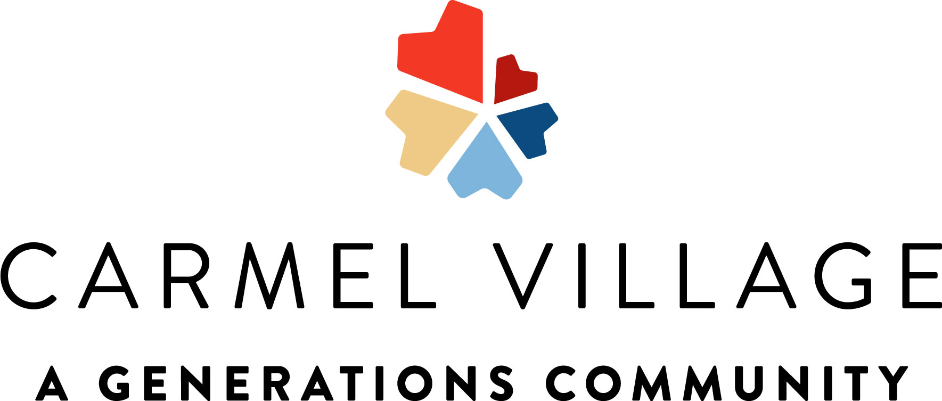 |  | Alzheimer’s and Brain Awareness Month  8:30 What is the Culture of the Month?  9:00 Chair Yoga  9:30 Hangman  10:15 Snack Break  11:00 Motor Skills Monday~ Stacking Red Cup Game  1:30 Pastor Phil  2:30 Afternoon Snack  3:15 Happy Hour~ Banana Cream Soda |  | 8:30 Morning News  9:00 Walking Club  9:30 Balloon Noodle Hockey  10:15 Snack Break  10:45 Reminiscing Conversations in the Patio  2:15 Cooking Class~ Dole Whips  2:30 Afternoon Snack  3:00 Residents Choice  4:00 Room Visits | 8:30 Morning Chat  9:00 Gentle Stretches  9:30 Guess the Country by Its Monument  10:15 Morning Snack  10:30 Room Visits  11:00 Lunch Outing~ Casa Maria  2:00 Music W/ Mathew Malcolm  2:30 Afternoon Snack  3:00 BINGO  4:00 Jeopardy | 8:30 Daily Chronical  9:00 Get Fit Stay Fit  9:30 Big Word Little Word  9:45 The price is Right  10:15 Snack Break  10:45 Crafty Crew~ Pressed Flower Bookmarks  2:45 Splash into Summer Social  2:45 Afternoon Snack | Wear Purple  8:30 Ted Talk: A 3 Step Guide to Believing in Yourself.  9:00 Walk Around the Neighborhood  9:30 Hangman  10:15 Snack Break  10:30 Trivia Crush Game  11:00 Men’s Recreational Club~UNO  2:00 Music W/ AL Turner  2:30 Afternoon Snack  2:30 Happy Hour~ Mango Chamoy Margarita Freeze  3:00 Room Visits | 10:15 Morning Snack  11:00 100 Questions Trivia  2:00 Law & Order  2:30 Afternoon Snack  3:00 Cinema Hour~ Ms. Doubtfire  Car Wash in AL Parking Lot  8-11am
Wear Purple  8:30 Sunday Morning Chat  9:30 Scenic Drive~ Reedley  10:15 Snack Break  11:00 Worship Music  2:00 Balloon Volleyball  2:30 Afternoon Snack  3:00 Room Visits | 8:30 Monday Morning Chat  9:00 Chair Yoga  9:30 Hangman  10:15 Snack Break  11:00 Alphabet Game  1:30 Motor Skills Monday~ Beach Ball Kickball  2:30 Afternoon Snack  3:15 Happy Hour~ Cold Iced Pistachio Latte |  | 8:30 Morning News  9:00 Walking Club  9:30 Jeopardy  10:15 Snack Break  10:45 Word Searches  2:15 Cooking Class~ Turkey Roll Ups  2:30 Afternoon Snack  3:00 Residents Choice  4:00 Room Visits |  | 8:30 Morning Chat  9:00 Gentle Stretches  9:30 Finish the Phrase Trivia  10:15 Morning Snack  10:30 Room Visits  11:00 Lunch Outing~ Foster’s Freeze  2:00 Music W/ David Press  2:30 Afternoon Snack  3:00 BINGO  4:00 Jeopardy | 8:30 Daily Chronical  9:00 Get Fit Stay Fit  9:45 The price is Right  10:15 Snack Break  2:00 Memory Matching Trivia  2:30 Afternoon Snack  3:00 Pretty Nails+ TV Sitcom | Wear Purple  8:30 Ted Talk: The Psychology of Self-Motivation.  9:00 Walk Around the Neighborhood  9:30 Hangman  10:15 Snack Break  10:30 Trivia Crush Game  11:00 Men’s Recreational Club~5 Jobs, 5 Places, 5 Names  2:00 Music W/ Miriam G  2:30 Afternoon Snack  2:30 Happy Hour~ Italian Cream Soda  3:00 Room Visits | 8:30 Sunrise Morning Chat  9:00 Chair Yoga  9:30 Animal Videos  10:00 Residents Choice Video  10:15 Morning Snack  11:00 Pretty Nails + TV Sitcom  2:00 BINGO  2:30 Afternoon Snack  3:00 Cinema Hour~ Fried Green Tomatoes + Popcorn
Wear Purple  8:30 Sunday Morning Chat  9:30 Scenic Drive~ Starbucks  10:15 Snack Break  11:00 Worship Music  2:00 Balloon Volleyball  2:30 Afternoon Snack  3:00 Room Visits | 8:30 Monday Morning Chat  9:00 Chair Yoga  9:30 Alphabet Game  10:15 Snack Break  11:00 Name that Tune  1:30 Motor Skills Monday~ Indoor Bowling  2:30 Afternoon Snack  3:15 Happy Hour~ Apple Fizz Mocktail |  | 8:30 Morning News  9:00 Walking Club  9:30 Balloon Noodle Hockey  10:15 Snack Break  10:45 Word Searches  2:15 Cooking Class~ Nutella Banana Kebabs  2:30 Afternoon Snack  3:00 Residents Choice  4:00 Room Visits |  | 8:30 Morning Chat  9:00 Gentle Stretches  9:30 Find the Difference  10:15 Morning Snack  10:30 Room Visits  11:00 Lunch Outing~ Taco Bell  2:00 Karaoke  2:30 Afternoon Snack  3:00 BINGO  4:00 Jeopardy | 8:30 Daily Chronical  9:00 Get Fit Stay Fit  9:45 The price is Right  10:15 Snack Break  10:45 Crafty Crew~ Father’s Day Centerpieces  1:30-3:30 Casino in AL Lobby  2:30 Afternoon Snack  3:00 America’ Got Talent Show | Juneteenth  Wear Purple  8:30 Ted Talk: What is Juneteenth? Why is it Important?  9:00 Walk Around the Neighborhood  9:30 History about Juneteenth  10:15 Snack Break  11:00 Juneteenth BINGO  2:15 Juneteenth Celebration  2:30 Afternoon Snack  3:00 Dining Room Set Up W/ Residents  Father’s Day Dinner  4:30pm | 8:30 Sunrise Morning Chat  9:00 Chair Yoga  10:15 Morning Snack  10:45 Pretty Nails + TV Sitcom  2:00 BINGO  2:30 Afternoon Snack  3:00 Cinema Hour~ Click + Popcorn
Happy Father’s Day  Wear Purple  8:30 Sunday Morning Chat  10:00 Coffee & Donuts w/ Dad/Grandpa  10:15 Snack Break  11:00 Worship Music  2:00 Field of Dreams Film  2:30 Afternoon Snack  3:00 Room Visits | 8:30 Monday Morning Chat  9:00 Chair Yoga  9:30 Big Word Little Word  10:15 Snack Break  11:00 Name that Tune  1:30 Motor Skills Monday~ Balloon Volleyball  2:30 Afternoon Snack  3:15 Happy Hour~ Root Beer Dirty Soda |  | Wear Pink  8:30 Daily Chronical  9:00 Get Fit Stay Fit  9:30 Old Wives Tales  10:15 Snack Break  10:45 Crafty Crew ~ Picture Frame DIY  2:30 Loteria Game  2:30 Afternoon Snack  3:00 Pretty Nails & TV Sitcom  4:00 Room Visits |  | 8:30 Morning Chat  9:00 Gentle Stretches  9:30 Finish the Phrase Trivia  10:15 Morning Snack  10:30 Room Visits  12:00 Chinese Luncheon in AL  2:00 Music W/ Randy  2:30 Afternoon Snack  3:00 BINGO  4:00 Jeopardy | National Strawberry Parfait Day  8:30 Daily Chronical  9:00 Get Fit Stay Fit  9:45 The price is Right  10:15 Snack Break  11:00 Mindfulness BINGO  2:30 Happy Social Month~ Strawberry Parfaits  2:30 Afternoon Snack  3:00 Residents Choice | Wear Purple  8:30 Ted Talk: The Power of Passion & Perseverance.  9:00 Morning Stroll  9:30 Hangman  10:15 Snack Break  10:30 Trivia Crush Game  11:00 Men’s Recreational Club~Jenga  2:00 Karaoke Hour  2:30 Afternoon Snack  2:00 Happy Hour~ Blueberry Lemon Spritzer  3:00 Room Visits | National BINGO Day  8:30 Sunrise Morning Chat  9:00 Chair Yoga  10:15 Morning Snack  10:45 Pretty Nails +TV Sitcom  2:00 BINGO  2:30 Afternoon Snack  3:00 Cinema Hour~ StageCoach + Popcorn
Wear Purple  8:30 Sunday Morning Chat  9:30 Scenic Drive~ Bus Driver Choice  10:15 Snack Break  11:00 Worship Music  2:00 New Joy Church  2:30 Afternoon Snack  3:00 Room Visits | 8:30 Monday Morning Chat  9:00 Chair Yoga  9:30 Fun Fact Trivia  10:15 Snack Break  10:30 Alphabet Game  11:00 Name that Tune  1:30 Motor Skills Monday~ Simon Says Challenge  2:30 Afternoon Snack  3:15 Happy Hour~ Blueberry Lavender Spritzer |  | National Meteor Watch Day  8:30 Morning News  9:00 Get Fit Stay Fit  9:30 Astronomy Trivia  10:15 Snack Break  10:45 Fun Facts about Meteors  2:15 Cooking Class~ Protein Oreo Cheesecake Dip  2:30 Afternoon Snack  3:00 Residents Choice  4:00 Room Visits |  | June 2026  Memory Care Calendar  Culture of the Month: Alzheimer’s and Brain Health Awareness Month
2145 Standford Ca #107208996 **Activities Subject to Change**
Sunday | Monday | Tuesday | Wednesday | Thursday | Friday | Saturday
 | 1 | 2 | 3 | 4 | 5 | 6
7 | 8 | 9 | 10 | 11 | 12 | 13
14 | 15 | 16 | 17 | 18 | 19 | 20
21 | 22 | 23 | 24 | 25 | 26 | 27
28 | 29 | 30

sssssssssss

