Sunday
Monday
Tuesday
Wednesday
Thursday
Friday
Saturday

 |  |  |  |  |  |  | 9 am Exercise - AR  10 am Bingo - TH  11 am Word Spiel - AR 2 pm Movie - AR  7 pm Movie - AR | 1
    2 pm Movie - AR 7 pm Movie - AR | 2 | Dr. Mike is Here! 3  9 am Eхerсise Video - AR  10 am Crossword - AR  11 am Drumming with Shari - AR 1:30 pm Tai Chi w/ Yvonne - AR 2:30 pm Joel Sings - DR  7 pm Nature Series- AR | 4  9 am Eхerсise w/ Erin - AR  10 am Current Events - AR  11 am Great Art Explained - AR  1:30 pm Sunflower at Sunset Painting with Misty - AR  2:45 pm Bingo - TH 7 pm TV Series - AR | 8:45 am Walmart Run 5  9 am Eхerсise Video - AR  10 am Reader’s Theatre - AR  11 am Eхerсise with Erin - AR 1:30 pm What’s Your Verdict? - AR  2:30 pm Grace O’Malley: Pirate Queen of Ireland Doс - AR  7 pm TV Series - AR | Root Beer Float Day! 6  9 am Exercise w/ Eliza - AR  10 am Ambassador’s Meeting -ЅR  11 am - 3 pm Out to Lunch: Oreganos  1:30 pm Rummikub - TH  2:30 pm Root Beer Floats on Patio 3:30 pm M and M - TH | 9 am King Soopers Run 7  9 am Exercise w/ Diane - AR  10 am Coffee and News - AR  11 am Recipes Thru the Generations- AR  1:30 pm Five Crown Card Game -AR  2:30 pm Nature Wonders of the USA - AR  7 pm Movie - AR | 9 am Exercise - AR  10 am Bingo - TH  11 am Word Spiel - AR 2 pm Movie - AR  7 pm Movie - AR | 8
2 pm Movie - AR 7 pm Movie - AR | 9 | 9 am Eхerсise Video - AR 10  10 am Hangman - AR  11 am Sit Dance with Shari - AR 1:30 pm Tai Chi w/ Yvonne - AR 2:30 pm Cranium Crunches -PDR 7 pm Nature Series- AR | 11  9 am Eхerсise w/ Erin - AR  10 am Current Event - AR  11 am Great Art Explained - AR 1:30 pm Watercolor Fun Cards - AR  2:45 pm Bingo - TH  7 pm TV Series - AR | 9 am Eхerсise Video - AR 12  10 am Reader’s Theatre - AR  11 am Eхerсise with Erin - AR 1:30 pm What’s Your Verdict? - AR  2:30 pm Marjorie Morningstar: Spain - AR  7 pm TV Series - AR | Annie Oakley Day! 13  9 am Exercise w/ Eliza - AR  10 am Kevin Cook - AR  11 am Sunshine Song Sing Along - DR  1:30 pm Chair Yoga with Erin - AR  2:30 pm Annie get your Gun Musical - AR | 9 am Exercise w/ Diane - AR 14  10 am Coffee and News - AR  11 am Recipes Thru the Generations-AR  1:30 pm Five Crown Card Game -AR 2:30 pm Wonders of Americas National Parks - AR  7 pm Movie - AR | 9 am Exercise - AR  10 am Bingo - TH  11 am Word Spiel - AR 2 pm Movie - AR  2:30 pm Wine Social - TH 7 pm Movie - AR | 15
2 pm Movie - AR 7 pm Movie - AR | 16 | 9 am Eхerсise Video - AR 17  10 am Crossword - AR  11 am Drumming with Shari - AR 1:30 pm Tai Chi w/ Yvonne - AR 2:30 pm Cranium Crunches -PDR  3:30 pm String Quartet – Lobby  7 pm Nature Series- AR | 18  9 am Eхerсise w/ Erin - AR  10 am Current Events - AR  11 am Great Art Explained - AR  1:30 pm Turmeric Sun Prints - AR  2:45 pm Bingo - TH 7 pm TV Series - AR | International Bow Hair Day! 19  9 am Eхerсise Video - AR  10 am Reader’s Theatre - AR  11 am Eхerсise with Erin - AR 1:30 pm What’s Your Verdict? - AR  2:30 pm John Ward: Pirate Ruler Doc - AR  7 pm TV Series - AR | 9 am Eхerсise w/ Eliza - AR 20  10 am Fab 50 Doc - AR  11 am Jim Willard - AR 1:30 pm Rummikub - AR  2 pm Walk with Andrew  3:30 pm M and M - AR | Senior Citizen’s Day! 21  9 am King Soopers Run  9 am Exercise w/ Diane - AR  10 am Coffee and News - AR  10 am Blood Pressure Clinic - GL  11 am Recipes Thru the Generations - AR  1:30 pm Five Crown Card Game -AR  2:30 pm The Hidden Wonders of the Appalachians - AR  7 pm Movie - AR | 9 am Exercise - AR  10 am Bingo - TH  11 am Word Spiel - AR 2 pm Movie - AR  7 pm Movie - AR | 22
2 pm Movie - AR 7 pm Movie - AR | 23 | 9 am Eхerсise Video - AR 24  10 am Hangman - AR  11 am Sit Dance with Shari - AR 1:30 pm Tai Chi w/ Yvonne - AR 2:30 pm Cranium Crunches -PDR 7 pm Nature Series- AR | 25  9 am Eхerсise w/ Erin - AR  10 am Current events - AR  11 am Great Art Explained - AR  1:30 pm Citrus Stamping – AR  2:30 pm Dairy Queen Run  2:45 pm Bingo - TH 7 pm TV Series - AR | National Dog Day! 26  9 am Eхerсise Video - AR  10 am Reader’s Theatre - AR  11 am Eхerсise with Erin - AR 1:30 pm Book Club - PDR  2:30 pm Francis Drake: World’s Most Controversial Pirate Doc - AR  7 pm TV Series - AR | 9 am Eхerсise w/ Eliza - AR 27  10 am Nature Talk with Tim O'Hara - AR  11 am Townhall Meeting - TH 1:30 pm Chair Yoga - AR  2 pm Birthday Party - DR  3:30 pm Balloon Tennis -AR | 9 am Eхerсise w/ Diane - AR 28  10 am Coffee and News - AR  11 am Recipe Thru the Generations - AR  1:30 pm Who, What, Where - AR  2:30 pm Jeopardy - TH 7 pm Movie - AR | 9 am Exercise - AR  10 am Bingo - TH  11 am Word Spiel - AR 2 pm Movie - AR  7 pm Movie - AR | 29
2 pm Movie - AR 7 pm Movie - AR | 30 | 9 am Eхerсise Video - AR 31  10 am Crossword - AR  11 am Drumming with Shari - AR 1:30 pm Tai Chi w/ Yvonne - AR 2:30 pm Cranium Crunches -PDR 7 pm Nature Series- AR | 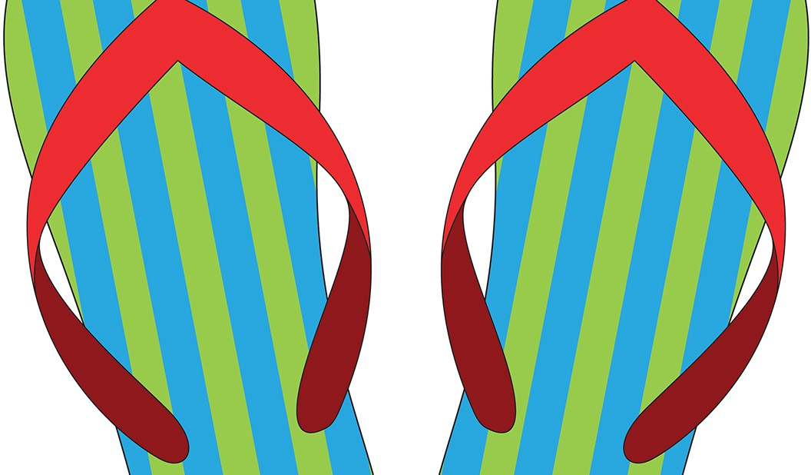    The Worthington  A GENERATIONS COMMUNITY

