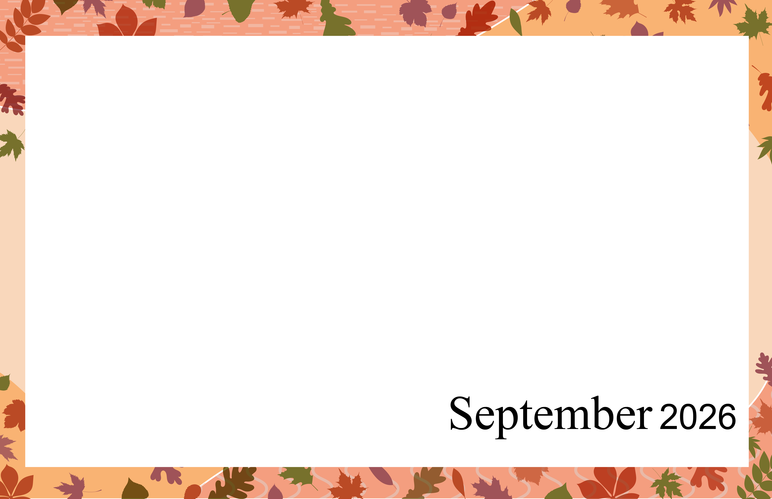Memory Care |  |  | 9:45 Exercise  10:30 Bingo!  1:30 Rosary- MR  2:00 Target Practice!  3:30“How the Beatles Changed the World” | 9:45 Exercise  10:30 Music Trivia!  2:00 Word Games: Scattergories!  3:30 Stretch & Unwind! | 9:30 RC Mass - MR  10:30 Group Charades!  2:00 Mocktails & Music Trivia!  3:30 Dispatches from the Forest – Secrets of the Prairie! - CDR | 9:45 Worship & Wisdom  12:00 End of Summer BBQ Social! – MC Park  2:00 Sound Affects Musical Performance -  CDR | 9:45 Exercise  10:30 Manicures  2:00 Seated Bowling  3:30 “Mighty Joe Young”
9:45 Exercise  10:30 Today in History: Coffee & Conversation!  2:00 Group Games!  3:30 Art Hour – Coloring & Classical Music | 9:45 Exercise  10:30 Pictionary!  2:00 Balloon Ball!  3:30 ATD Pety Therapy | 9:45 Exercise  10:30 Bingo!  1:30 Rosary - MR  2:00 Sunflower Card Craft!  3:30 “M*A*S*H* - The Comedy that Changed TV” |  | 10:30 Senior Serenaders - CDR  2:00 Word Games: Bananagrams!  3:30 1:1’s with Residents | Happy Birthday Mary Anne S.!  9:45 Exercise  10:30 Hymns with Lynn - CDR  2:00 Music with Scott - CDR  3:30 “The Hundred-Foot Journey” | 9:45 Exercise  10:30 Worship & Wisdom  2:00 Hula Hoop  Chair-obics  3:30 Snack Pass & Short Stories! | 9:45 Exercise  10:30 Manicures  2:00 Balloon Volleyball!  3:30 “9 to 5”
9:45 Exercise  10:30 Today in History: Coffee & Conversation!  2:00 Group Games!  3:30 Art Hour – Coloring & Classical Music | 9:45 Exercise  10:30 Russell Risma! – CDR  11:15 Communion - MR  2:00 Balloon Ball!  3:30 Brain Teasers! | 9:45 Exercise  10:30 Bingo!  1:30 Rosary - MR  2:00 Target Practice  3:30 “New Life Under the Sea” |  | 9:30 Exercise  10:15 Music with Kendra! - CDR  2:00 Word Games: Pictionary!  3:30 Stretch & Unwind! | 9:45 Exercise  10:30 Group Charades!  2:00 Resident Birthday Bash! -CDR  3:30 “The Vaults of the Smithsonian” | 9:45 Exercise  10:30 Worship & Wisdom  2:00 Sound Affects Musical Performance- CDR  3:30 Snack Pass & Short Stories! | 9:45 Exercise  10:30 Manicures  2:00 Seated Bowling!  3:30 “Mouse Hunt”
9:45 Exercise  10:30 Today in History: Coffee & Conversation!  2:00 Group Games!  3:30 Art Hour – Coloring & Classical Music | 9:45 Exercise  10:30 Minute to Win it Games!  2:00 Balloon Ball  3:30 ATD Pet Therapy | 9:45 Exercise  10:30 Bingo!  1:30 Rosary - MR  2:00 Fall Leaf Suncatcher Craft!  3:30 “Autumn of the Heart” |  | 9:45 Exercise  10:30 Music Trivia!  2:00 Word Games: Scattergories!  3:30 1:1’s with Residents | 9:45 Exercise  10:30 Hymns with Lynn - CDR  2:00 Mocktails & Music Trivia!  3:30 “101 Dalmatians’” | 9:45 Exercise  10:30 Worship & Wisdom  2:00 Oktoberfest Party! - CDR | 9:45 Exercise  10:30 Manicures  2:00 Balloon Volleyball!  3:30 “The Secret Garden”
9:45 Exercise  10:30 Today in History: Coffee & Conversation!  2:00 Group Games!  3:30 Art Hour – Coloring & Classical Music | 9:45 Exercise  10:30 Pictionary!  11:15 Communion - MR  2:00 Balloon Ball  3:30 Brain Teasers! | 9:45 Exercise  10:30 Bingo!  1:30 Rosary- MR  2:00 Target Practice!  3:30 Short Fall Stories & Snacks! |  | 9:45 Exercise  10:30 Music Trivia!  2:00 Word Games: Bananagrams!  3:30 Stretch & Unwind! | *Activities subject to change
Sunday | Monday | Tuesday | Wednesday | Thursday | Friday | Saturday
 |  | 1 | 2 | 3 | 4 | 5
6 | 7  Labor Day | 8 | 9 | 10 | 11  Rosh Hashanah Begins | 12
13  Grandparents Day | 14 | 15 | 16 | 17 | 18 | 19  Oktoberfest Begins
20  Yom Kippur Begins | 21 | 22  Autumn Begins | 23 | 24 | 25  Sukkot Begins | 26
27 | 28 | 29 | 30

