Memory Care |  |  |  | 9:30 Mass - MR  10:30 Exercise  2:00 Art Hour – Coloring & Classical Music!  3:30 Dispatches from the Forest – “The Amazing World of Bats!” - CDR | Happy Birthday Phyllis R.!  9:45 Exercise  10:30 Wisdom & Worship  2:00 Sound Affects - Musical Performance!  3:30 ZenZone: Stretch & Unwind | 9:45 Exercise  10:30 Manicures!  2:00 Balloon Soccer!  3:15 “The House with a Clock in its Walls”
9:45 Exercise  10:30 Today in History: Community Coffee & Conversations  2:00 Broncos Vs 49ers  3:00 1:1’s with Residents | 9:45 Exercise  10:30 Fall Pictionary!  2:00 Pumpkin Bowling!  3:30 Halloween Charm Bracelet Craft! - LIB | Larimer County Election Assistance Visits (9am – 1pm)  10:00 Exercise  10:30 Bingo!  1:30 Rosary – MR  2:00 Pumpkin Bowling  3:30 Hot Apple Cider & Short Stories! | 9:45 Exercise  10:30 Music Trivia!  2:00 Word Games: Fall Scattergories!  3:30 Mocktails & Halloween Charades! | 9:45 Exercise  10:30 Hymns with Lynn!  2:00 Music with Scott! - CDR  3:30 Thriller Theatre  Thursdays: “Hocus Pocus” | 9:45 Exercise  10:30 Wisdom & Worship  2:00 Group Games: Halloween Singo- Bingo!  3:30 Art Hour – Coloring & Classical Music! | Happy Birthday Mary Jo O.!  9:45 Exercise  10:30 Manicures!  2:00 Balloon Ball!  3:30 Monster Milkshake Pass!
9:45 Exercise  10:30 Today in History: Community Coffee & Conversations  2:00 Broncos vs. Chargers  3:00 1:1’s with Residents | 9:45 Exercise  10:30 Russell Risma! – CDR  11:15 Communion - MR  2:00 Zombie Target Practice!  3:00 Hot Apple Cider &  Short Stories! | 10:00 Fall Café Cart!  1:30 Rosary - MR  2:00 Bingo!  3:30 Caramel Apple Dessert Cups & Group Games! | 10:30 Senior Serenaders! - CDR  2:00 Balloon Ball!  3:30 Halloween Craft: Skeleton Chain Door-naments! - LIB | 9:45 Exercise  10:30 Art Hour – Coloring & Classical Music!  2:00 Resident Birthday Bash!  3:30 Thriller Theatre  Thursdays: “Casper” | 9:45 Exercise  10:30 Wisdom & Worship  2:00 Sound Affects - Musical Performance!  3:30 Resident & Staff - Mini Pumpkin Painting! - LIB | 9:45 Exercise  10:30 Manicures!  2:00 Witch Hat Ring Toss!  3:30 Halloween Cartoon Marathon & Snack Pass
9:45 Exercise  10:30 Today in History: Community Coffee & Conversations  2:00 Halloween Jeopardy  3:30 1:1’s with Residents | 9:45 Exercise  10:30 “Roll a Pumpkin” Craft!  2:00 Halloween Scattergories!  3:30 ZenZone: Stretch & Unwind | 9:45 Exercise  10:30 Bingo!  1:30 Rosary - MR  2:00 Foam Pumpkin Jack-o-lantern Ornament Craft  3:30 Hot Apple Cider & Short Stories! | 9:45 Exercise  10:30 Halloween Roll-a-Story Game!  2:00 Balloon Ball  3:30 Mocktails & Halloween Charades! | 9:45 Exercise  10:30 Hymns with Lynn! - CDR  2:00 Art Hour – Coloring & Classical Music!  3:30 Thriller Theatre  Thursdays: “Goosebumps 2 – Haunted Halloween” | 9:45 Exercise  10:30 Wisdom & Worship  2:00 Group Games: Halloween Singo- Bingo!  3:30 Witch Hat Ring Toss! | Happy Birthday Loren C.!  9:45 Exercise  10:30 Manicures!  2:00 Balloon Soccer  3:30 Fall Watercolor Painting
9:45 Exercise  10:30 Today in History: Community Coffee & Conversations  2:00 Broncos Vs. Cardinals  3:00 Halloween Piano Recital! - CDR | 10:30 Halloween Scavenger Hunt!  11:15 Communion - MR  2:00 Ghost Target Practice  3:30 Hot Apple Cider &  Short Stories! | 10:00 Fall Café Cart!  1:30 Rosary - MR  2:00 Bingo!  3:30 Group Games: Halloween Trivia & Treats! | 9:30 Exercise  10:15 Music with Kendra - CDR  2:00 Pumpkin Bowling!  3:30 Halloween Craft: Paper Plate Jack-o-Lanterns! - LIB | 9:45 Exercise  10:30 Art Hour – Coloring & Classical Music!  2:00 Pass the Pumpkin Prize Game!  3:30 Thriller Theatre  Thursdays: “Scooby Doo: The Movie” | 9:45 Exercise  10:30 Halloween Cookie Decorating!  12:30 – Costume Parade & Contest!  2:00 Fall-O-Ween Fest! | Happy Halloween!  10:30 Wisdom & Worship  2:00 Manicures!  3:00 Spooky Sweet Treat Pass!  3:15 “Scary Godmother Halloween Spooktacular”
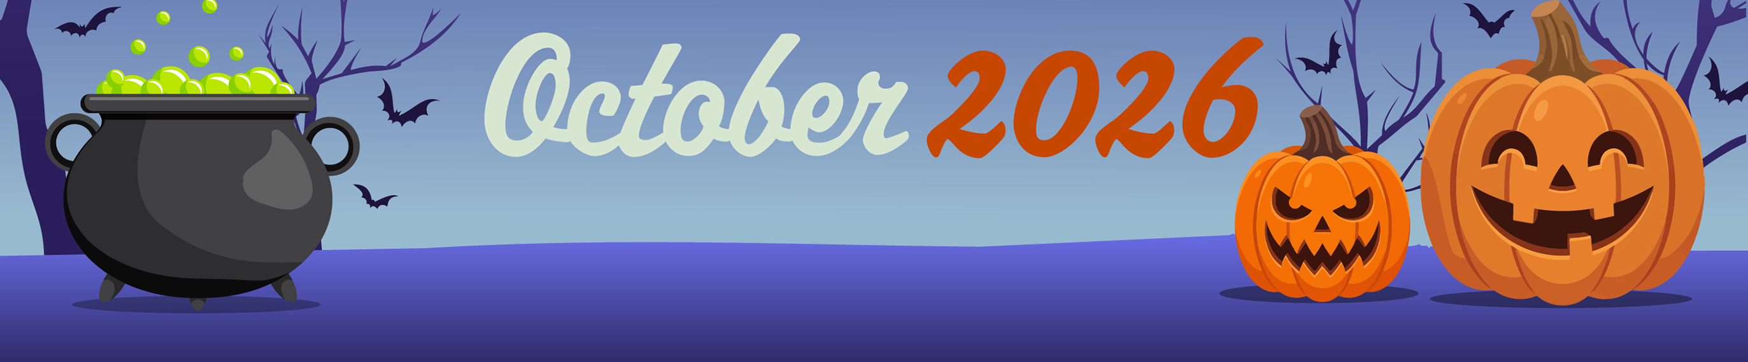
- Activities are subject to change
Sunday | Monday | Tuesday | Wednesday | Thursday | Friday | Saturday
 |  |  |  | 1 | 2 | 3  Simchat Torah Begins
4 | 5 | 6 | 7 | 8 | 9 | 10
11 | 12  Indigenous Peoples’ Day  Columbus Day (U.S.)  Thanksgiving Day (Canada) | 13 | 14 | 15 | 16 | 17
18 | 19 | 20 | 21 | 22 | 23 | 24
25 | 26 | 27 | 28 | 29 | 30 | 31  Halloween

